Case Study 8: Student Academic Risk Classification

1. Problem Statement
Develop a Python program to classify students based on their academic performance using marks and attendance percentage. The program should accept student details, validate the input, and classify students into different academic risk categories such as Low Risk, Medium Risk, and High Risk. The program should display the student's details and academic risk level.

2. Objectives
To accept student marks and attendance percentage.
To validate marks and attendance values.
To classify students based on academic performance.
To identify students who may need additional academic support.
To display student details and their risk category.

3. Assumptions
Student marks are entered out of 100.
Attendance is entered as a percentage.
Marks must be between 0 and 100.
Attendance must be between 0% and 100%.
The following classification rules are assumed for this case study:
Condition | Risk category
Marks ≥ 75 and attendance ≥ 75% | Low Risk
Marks ≥ 50 and attendance ≥ 60%, but not Low Risk | Medium Risk
Marks below 50 or attendance below 60% | High Risk
- These thresholds are illustrative and can be changed according to university rules.

4. Algorithm
- Start the program.
- Input the student's name.
- Input marks out of 100.
- Input attendance percentage.
- Check whether marks and attendance are within the valid ranges.
- If the values are invalid, display an error message.
- If marks are at least 75 and attendance is at least 75%, classify the student as Low Risk.
- Otherwise, if marks are at least 50 and attendance is at least 60%, classify the student as Medium Risk.
- Otherwise, classify the student as High Risk.
- Display the student's name, marks, attendance, and risk category.
- Stop the program.

5. Flowchart

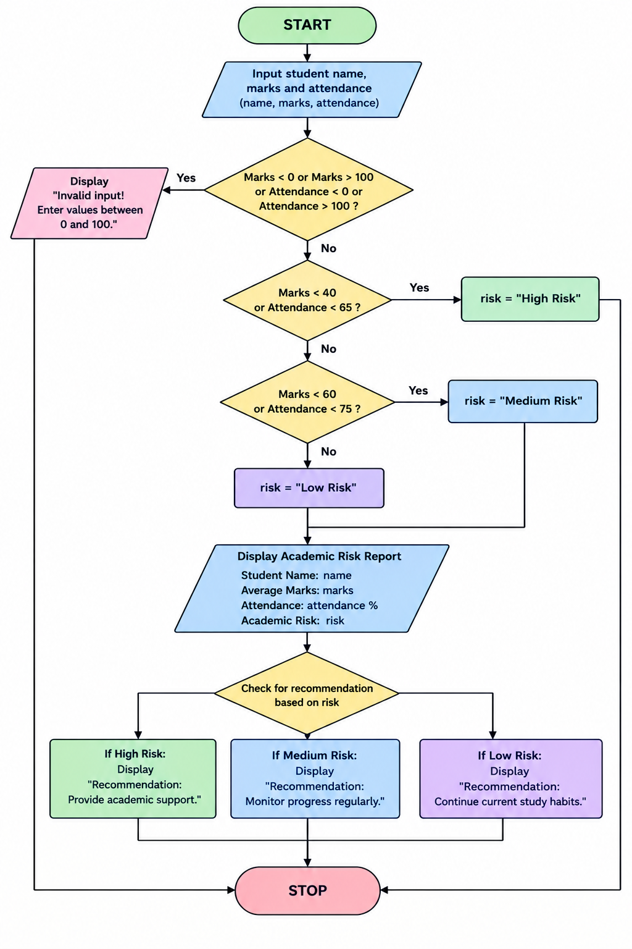

6. Pseudocode
START

INPUT student_name
INPUT marks
INPUT attendance

IF marks < 0 OR marks > 100 OR
attendance < 0 OR attendance > 100 THEN
DISPLAY "Invalid input"

ELSE
IF marks >= 75 AND attendance >= 75 THEN
risk = "Low Risk"

ELSE IF marks >= 50 AND attendance >= 60 THEN
risk = "Medium Risk"

ELSE
risk = "High Risk"
END IF

DISPLAY student_name
DISPLAY marks
DISPLAY attendance
DISPLAY risk
END IF

STOP

7. Test Cases
Test case | Marks | Attendance | Expected result
1 | 85 | 90% | Low Risk
2 | 65 | 70% | Medium Risk
3 | 40 | 80% | High Risk
4 | 80 | 50% | High Risk
5 | 110 | 85% | Invalid input
6 | 70 | -10% | Invalid input

8. Output

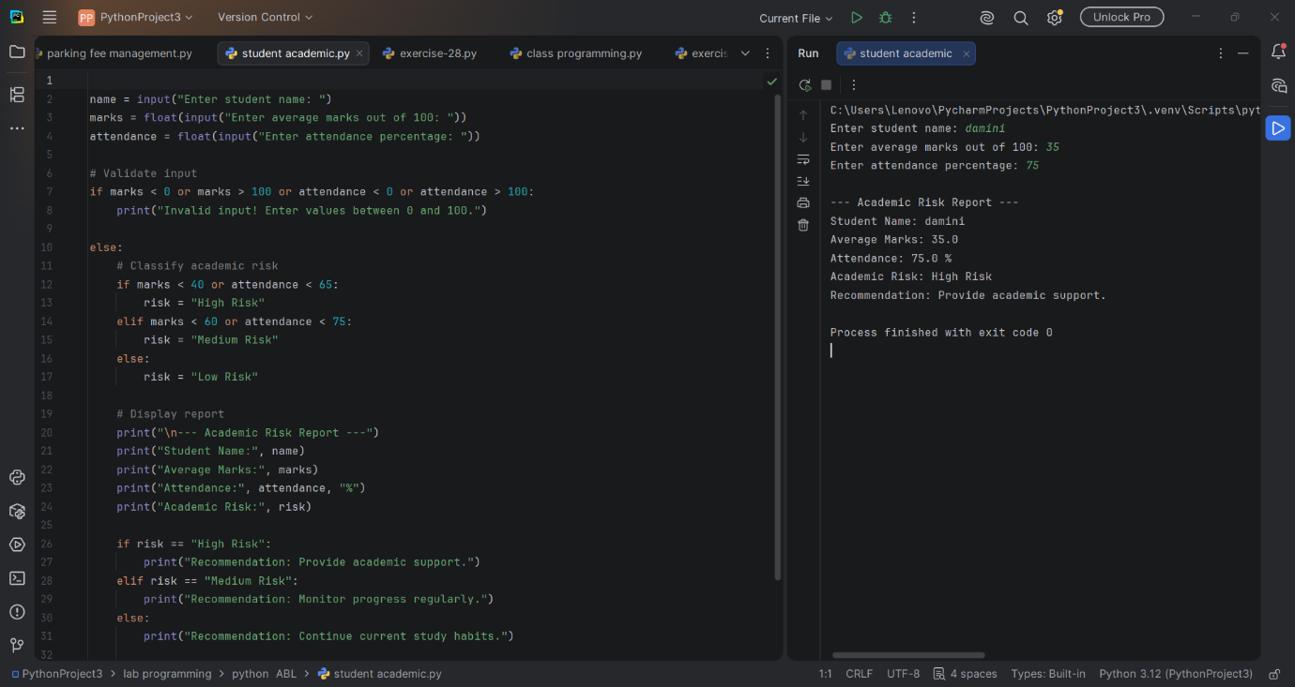

9. Conclusion
The Student Academic Risk Classification program evaluates students using their marks and attendance percentage. It categorizes students into Low Risk, Medium Risk, or High Risk based on predefined conditions. This program demonstrates the use of Python conditional statements, logical operators, and input validation. It can help identify students who may benefit from additional academic support, while the classification should be used as a guide rather than a definitive judgment of a student's ability.

